**1. PROJECT TITLE:**

**RideNNFCNN:A new Hybrid Machine Learning Network for Age Prediction using EEG Signal**

**2. HARDWARE REQUIREMENTS**

OS-Windows 10

RAM-8GB

ROM-More than 100 GB

GPU-Yes

CPU-1.7 GHz

**3. SOFTWARE REQUIREMENTS**

Software name(**Python**): Version: 3.9.11

(Download link: <https://www.python.org/downloads/release/python-3911/>)

Click -> Windows installer (64-bit).

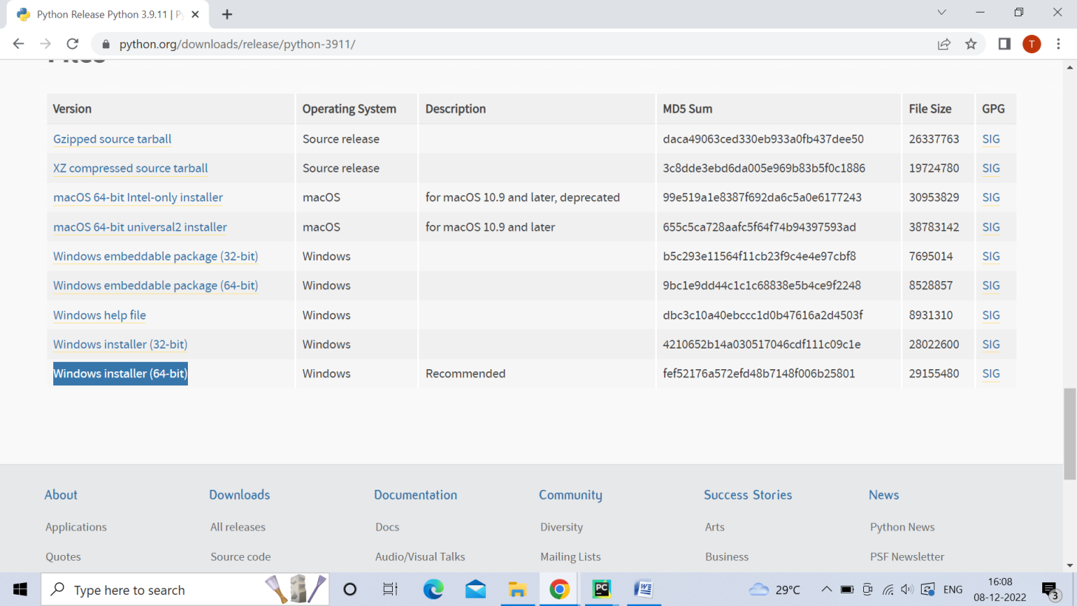

Software name: **PyCharm**: Version: 2020.3.3

(Download link: <https://www.jetbrains.com/pycharm/download/other.html>)

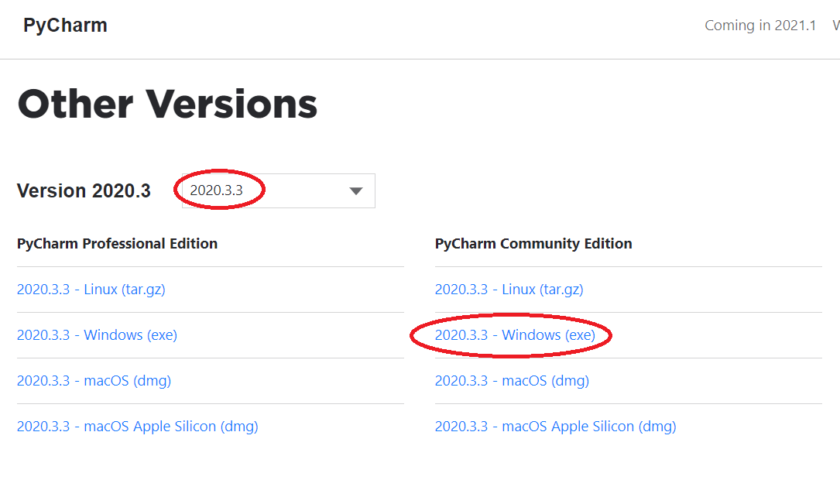

(For installation procedure, please refer the doc “steps to install python.doc”)

**4. HOW TO RUN**

**Step 1**: Loading the project in PYCHARM

* Open pycharm
* Go to File, select Open browse the project from your drive and select it. So that the project will get loaded into the Pycharm.
* For the first time, Pycharm will take some time to load the settings.
* Please wait if any process is loading on the bottom of the screen.
* Check the Project Interpreter (File -> Settings -> Project: final code -> Project Interpreter).

If this location “(C:\Users\---\AppData\Local\Programs\Python\Python39\python.exe) is not presented, then add this ‘python.exe’ from the installed location.

* In Pycharm Terminal(bottom left), type the comment “pip install -r requirements.txt”

**Step 2**: Run the program and getting the results

* From 'current project folder' window in pycharm, Open ‘**237915-> Main -> GUI.py**’ and click run button
* In GUI window
  + Select the dataset
  + Select the Training data(%) or k-fold and enter values[‘50’,‘60’,’70,’80’,’90’]
  + Click START, after some time the result will be displayed

[Expected Execution time expected: **5-10 minutes**]

**Step 3**: Generate the graphs plotted in the paper

* From 'current project folder' window in pycharm, open ‘Result_graphs.py’, and click run button.

**5. IMPORTANT PYTHON FILE AND DESCRIPTION:**

GUI.py:User Interface to select the dataset, code starts here

Run.py: Main code starts here

process.py: preprocessing, features extraction (spectral based features, frequency-based features, statistical features, frequency domain features decomposition domain)

Proposed-> CNN.py

Result_graphs.py: displays graphs included in the paper.